Project: Active Directory Brute-Force Detection & SIEM Correlation
Objective
To engineer a functional security pipeline that detects unauthorized authentication attempts on a Windows Server 2022 domain environment using Wazuh SIEM and Kali Linux. This project demonstrates the ability to configure endpoint telemetry, simulate an adversary's tactics, and verify the resulting security correlation.
Phase 1: Endpoint Hardening & Audit Policy Configuration
Standard Windows installations do not provide the granular visibility required for modern threat detection. To establish a baseline for visibility, the following configurations were applied:
- Policy Initialization: Accessed the Local Security Policy console via secpol.msc to initialize advanced audit configurations for the domain environment.
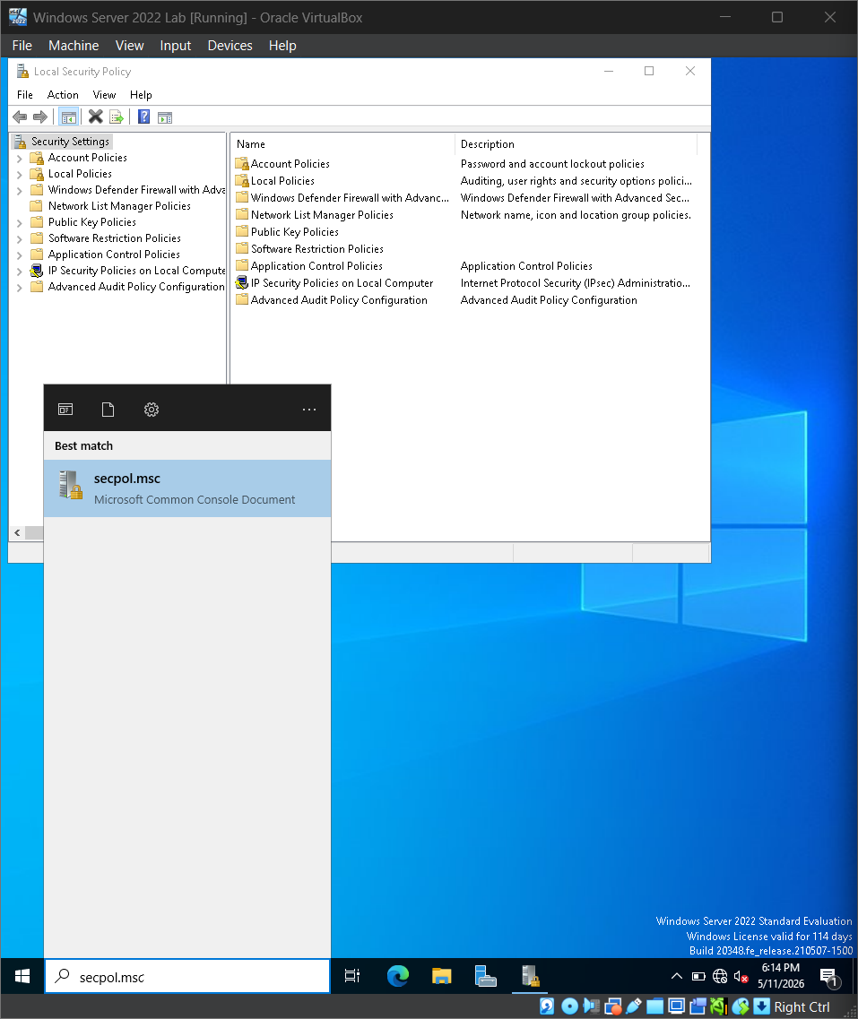
Accessing the Windows Local Security Policy console to initialize advanced audit configuration.
- Telemetry Activation: Navigated to Security Settings > Local Policies > Audit Policy and enabled Success and Failure auditing for both Logon events and Account logon events. This ensures the generation of Event ID 4625 (Logon Failure) telemetry for all unauthorized attempts.

- Navigate to: Security Settings > Local Policies > Audit Policy. Find Audit logon events and Audit account logon events. Double-click each and check both Success and Failure. Click Apply.
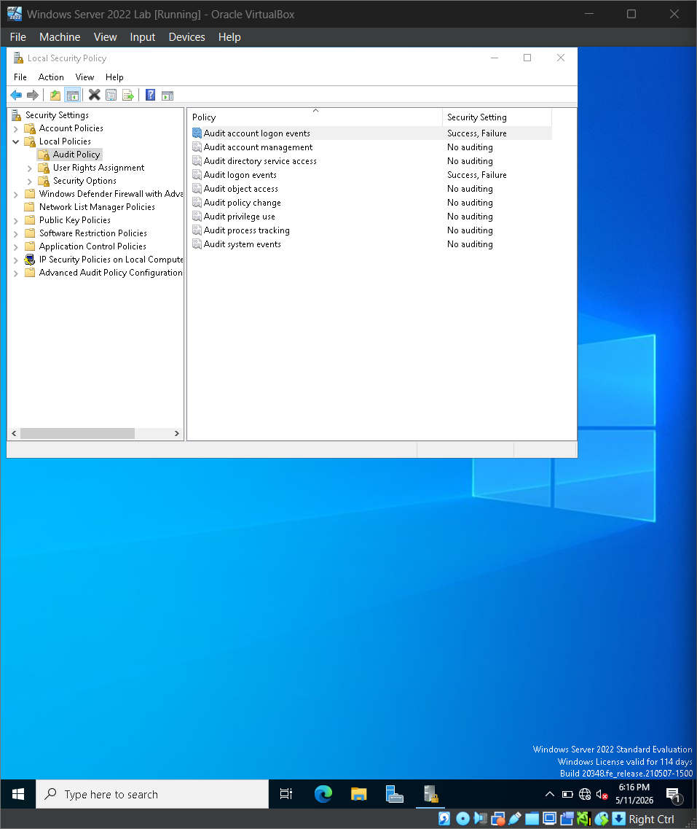
Enabling 'Success' and 'Failure' auditing for logon events to ensure the generation of Event ID 4625 telemetry.

Provisioning Targeted Identity: Utilized PowerShell (Admin) to provision a sacrificial local user, Finance_Manager, establishing a high-value target for adversary credential guessing simulations.
Run this command to create a fake user for the test. New-LocalUser -Name “Finance_Manager” -Description “Test account for SOC lab” -Nopassword
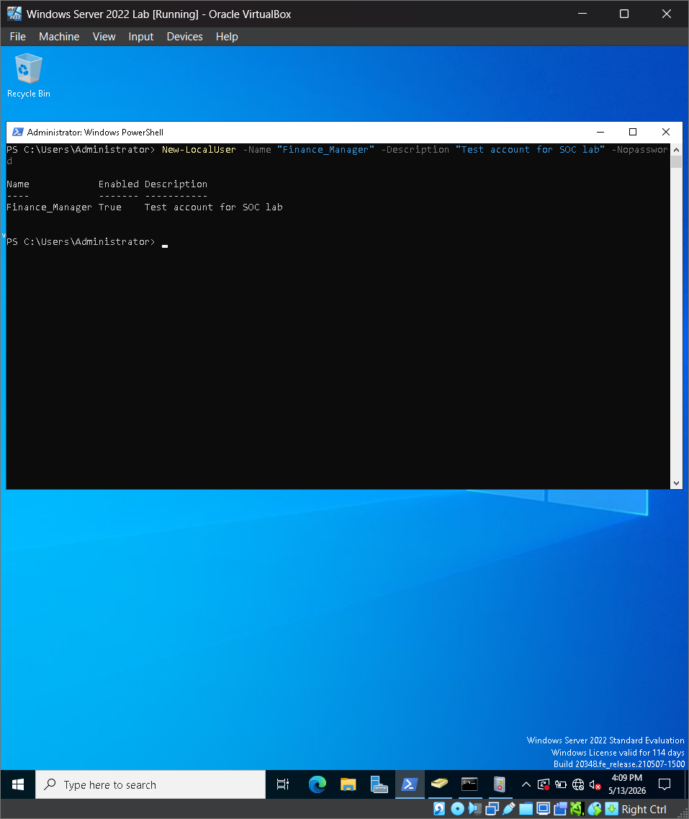
Utilizing PowerShell to provision the Finance_Manager sacrificial account.
Phase 2: Adversary Simulation (Simulating Brute Force)
With telemetry active, a controlled "Password Spray" attack was simulated from an external adversary platform to test the SIEM’s alerting thresholds.
- Platform Execution: Utilized a Kali Linux instance to execute network-based authentication requests against the target.
- Attack Mechanism: Deployed a bash loop leveraging smbclient to attempt 10 consecutive failed logins against the target Windows Server IP (192.168.10.10).
- Command Logic: for i in {1..10}; do smbclient -L //192.168.10.10 -U Finance_Manager%WrongPass; done.
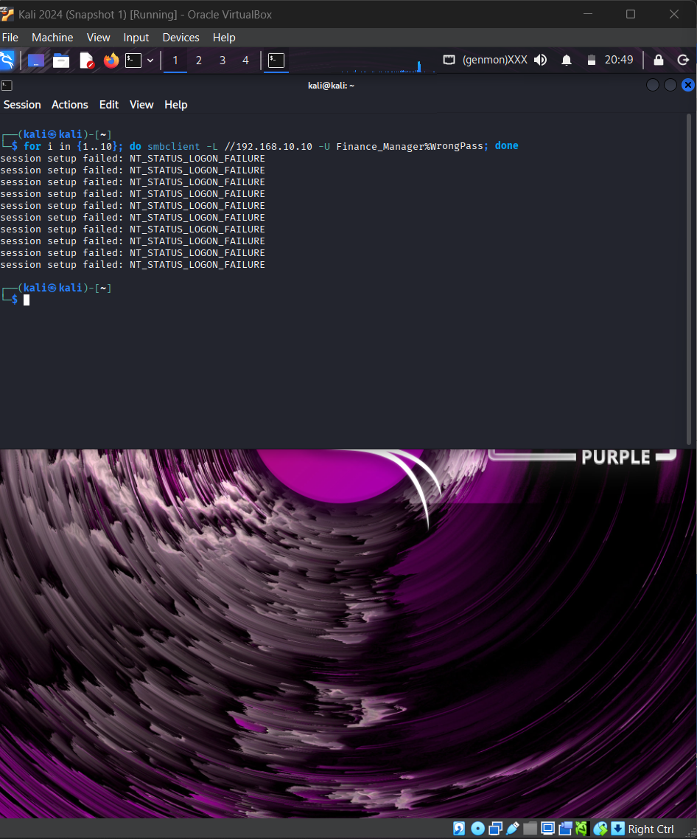
Executing a controlled SMB brute-force attack from Kali Linux to generate rapid authentication failures.
Phase 3: Forensic Analysis & SIEM Validation
The final phase validates that the generated "noise" was successfully ingested, parsed, and correlated by the SOC stack.
- Log Verification: Accessed the Windows Event Viewer and applied a filter for Event ID 4625 to confirm the local generation of audit failures following the attack.
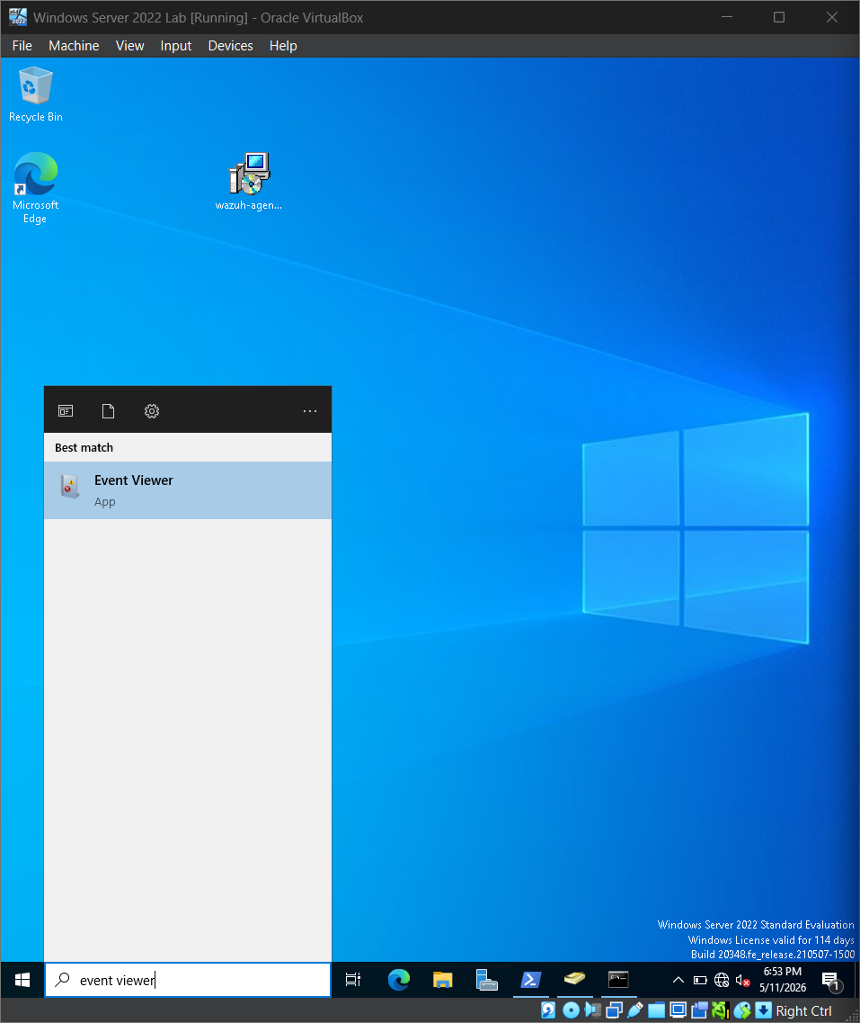
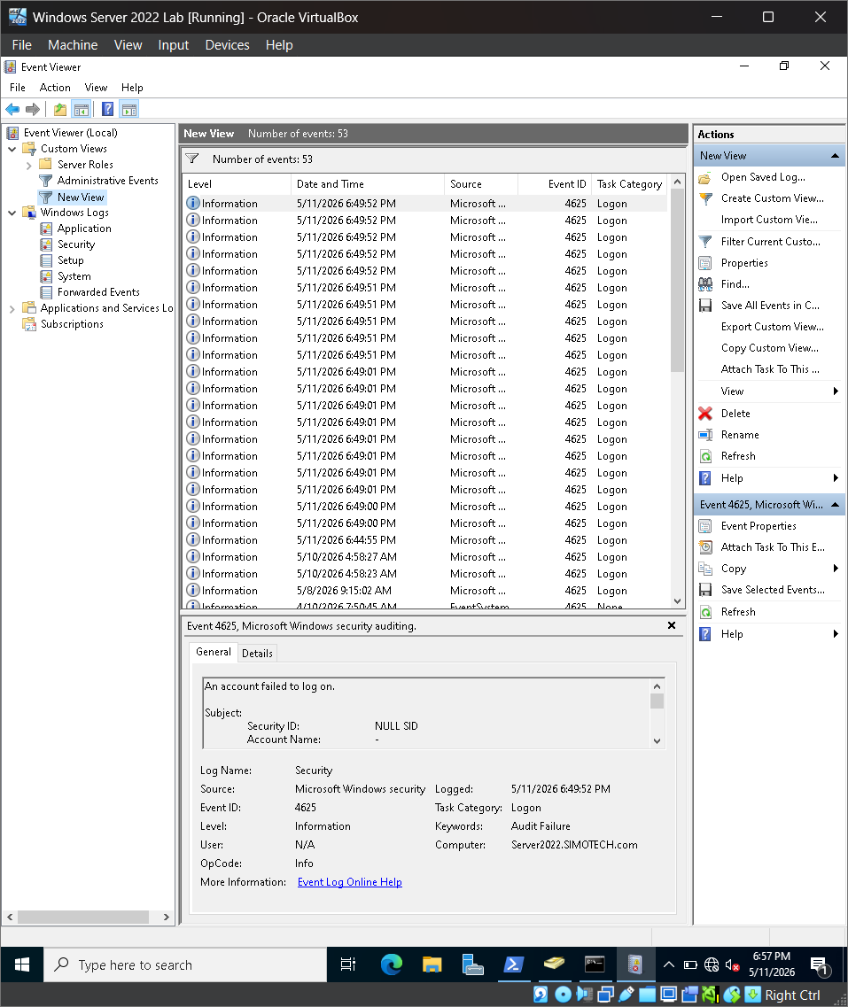
Reviewing the Windows Security Log to verify the local generation of Audit Failure events.

SIEM Correlation: Navigated to the Wazuh Dashboard to verify that the individual failure logs were correlated into a high-priority security event.
Detection Integrity: Successfully identified Rule 60204 (Multiple Windows Logon Failures), confirming that the SIEM correctly flagged the attack pattern and mapped it to global security frameworks like PCI DSS.
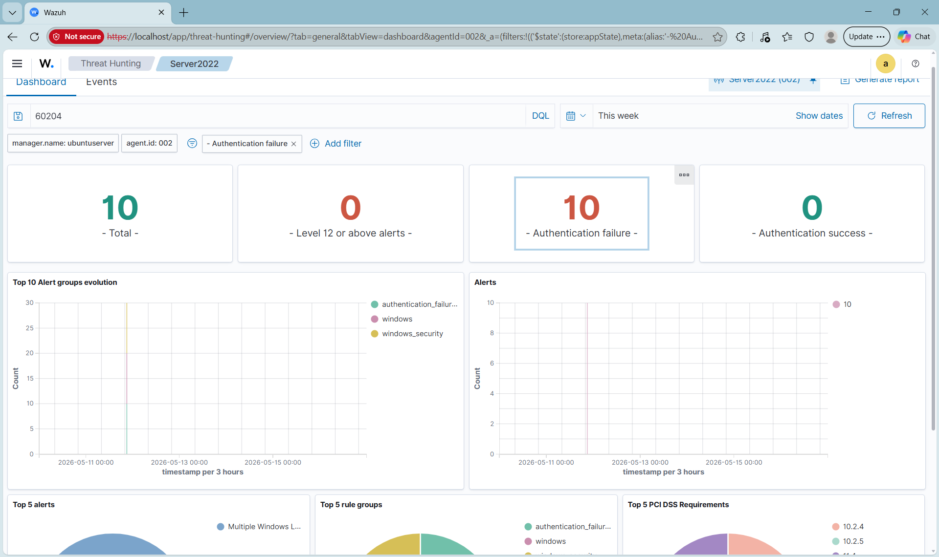
Wazuh SIEM Dashboard displaying the successful correlation of raw logs into a High-Severity (Level 10) Brute-Force alert.
Lessons Learned & Mitigation Strategies
- Remediation Suggestion (Account Lockout Policy): To proactively mitigate password spray and brute-force attacks, it is recommended to implement a strict Account Lockout Policy via Group Policy Objects (GPO). Setting a threshold to lock accounts after 3 failed attempts within a specific window significantly increases the cost of the attack for an adversary and prevents automated credential guessing.
- Resource Management: During the detection phase, the SIEM indexer required a manual resource increase to 2 vCPUs and 4GB RAM to handle high-volume telemetry indexing without causing a system lockup.
- Network Persistence: Identified and resolved a "post-crash" connectivity issue where secondary network interfaces (enp0s8) required manual IP re-assignment (192.168.10.5) to restore the telemetry heartbeat between the agent and the manager.
- Compliance Mapping: Successfully demonstrated how technical alerts map to global security standards, specifically addressing PCI DSS 10.2.4 and 10.2.5 regarding the monitoring of all administrative access and failed authentication attempts.

